Westbrook 5th Ward History 2022
Unit #: 174335
By: Bruce Holman
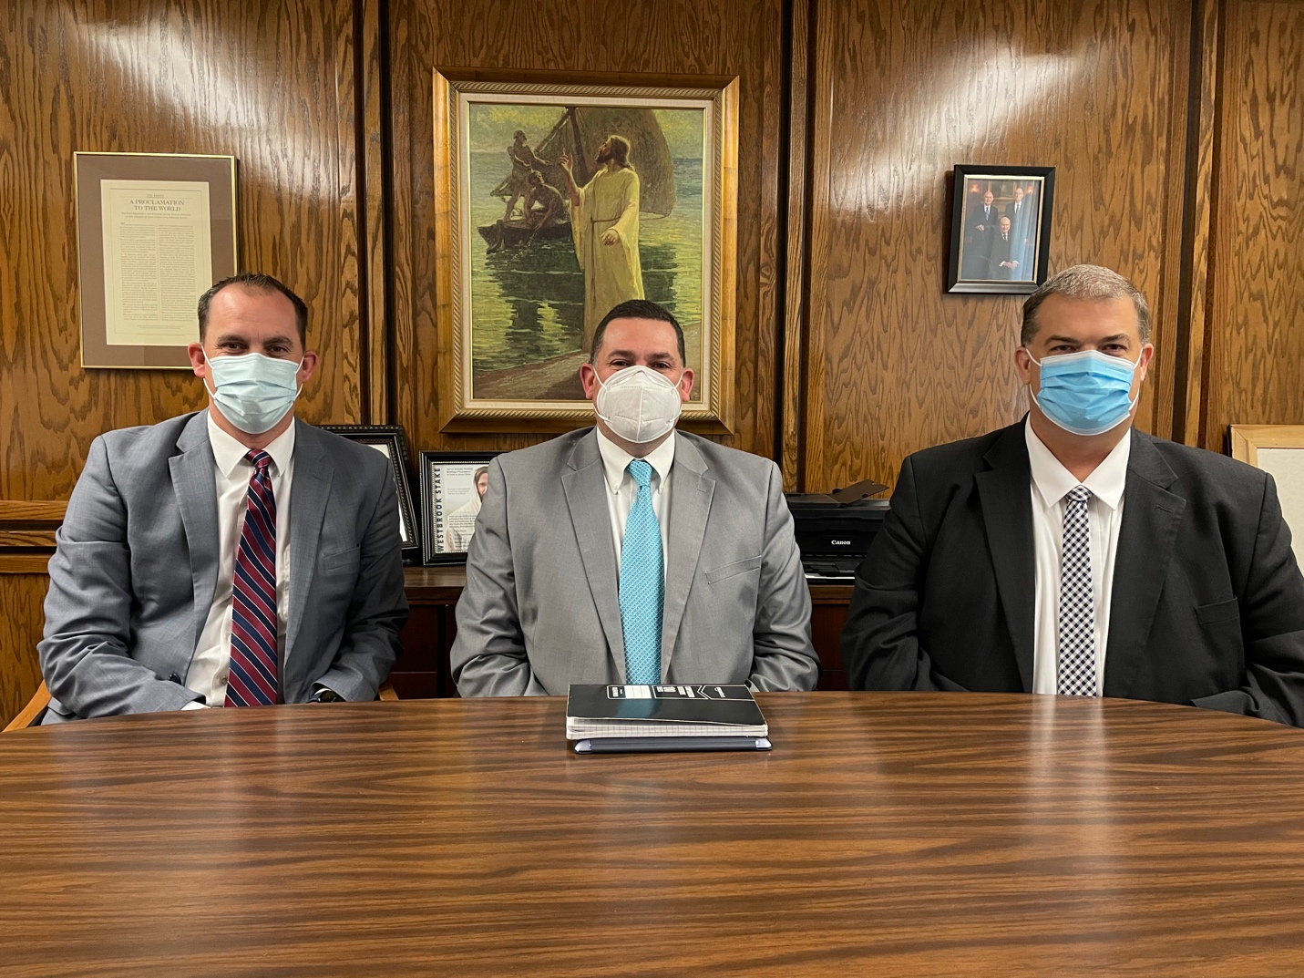
Kurt Allen, Bishop Matt Ekker, Bret Smith

2022 continued with virtual sacrament and in person sacrament meeting at 12:00. This year’s study is the Old Testament in Sunday school.

February 27 – Ward Conference
Brother Prescott from the High Council read the sustaining vote as follows for the ward:
It is proposed that we sustain as the bishopric and presidency of the Aaronic Priesthood in the Westbrook 5th ward: Matthew John Ekker as bishop, with Kurt Arthur Allen as first counselor and Bret Kevin Smith as second counselor. Those in favor manifest it. Any opposed manifest it. As ward clerk: Michael Ray Christensen: as ward executive secretary: Brad L Bona, as assistant ward clerk: Ryan Thomas Stowe. Those in favor manifest it. Any opposed manifest it.
It is proposed that we sustain: As the presidency of the elder’s quorum located in the Westbrook 5th Ward: Jarl Kenneth Jacobson Jr, president; Scott Arno Rosenlof, first counselor; and Brady Scott Patterson, second counselor; Brian Barlow, secretary.
As the presidency of the Relief Society: Shanna Lee Hansen, president; Anne Marie Paxman, first counselor; and Aurea Bautista Gregorio, second counselor; with Lisa Stowe, secretary.
As the presidency of the Primary: Rebekah Goodwin, president; Susan Jane Holman, first counselor; and Julie Turner, second counselor; with Natalie Kathryn Smith, secretary.
As the presidency of the Sunday School: David Danie Platt Drake, president; Matthew Douglas Cannon, first counselor; George William Bell, second counselor; with _________________________, secretary.
As the presidency of the Young Women: Natalie Ann Bona, president; Debra Alexus Ekker, first counselor; and Ruth Jacobson, second counselor; with Shantel Michelle Olson, secretary.
As ward mission leader: Sheldon Reed LaMont, As ward temple and family history eader: Scott Arno Rosenlof.
All other ward officers and teachers as now constituted. Those in favor manifest it. Any opposed manifest it.
As president of the priest’s quorum: Matthew John Ekker, bishop; with Isaiah William Fowers, first assistant; Aaron Espinosa Bautista, second assistant; secretary.
As the presidency of the teacher’s quorum: Nicholas Gregory Stowe, president; Hiram Scott Patterson, first counselor; and Axel Espinosa Bautista, second counselor; with Aaron Matias Flores Guevara, secretary.
As the presidency of the deacon’s quorum: Vaimalili Aso’ese Malili, president; Hayden Joseph Bona, first counselor; and , second counselor; with, secretary.
As the presidency of the YW 15-18 class: Sarah Christina Ekker, president; Alyssa Kathleen Hansen, first counselor; and Natasha Paige Barlow, second counselor; with Arianna Kae Turner, secretary.
As the presidency of the YW 12-14 class: Maggie Alece Johnson, president; Riley Aileen Barlow, first counselor; and Afton Virginia Garritson, second counselor; with Jaylynn Monserrah Watson, secretary. Those in favor manifest it. Any opposed manifest it.
For the information of ward members, the number of members of the ward serving proselyting, service, and senior missions is 6.

March 26 - Ward dinner and speaker
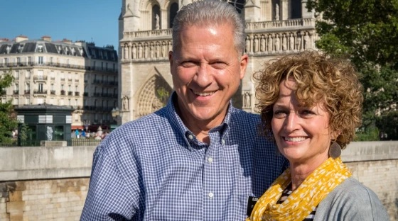
Richard Norby and wife
“When the Brussels international airport was bombed in 2016, missionary Richard Norby was terribly burned and injured by shrapnel. Yet in that moment, he knew the Savior was there for him and everything would be OK. The Savior is there for you, too.”
“I also had an overwhelming and greater appreciation for the fact that the Savior had suffered for all of our pains and sorrows and inabilities and inadequacies.”

April 10 – New Stake Presidency
President Paul Stakie, 1st. Counselor Rick Kitchens, 2nd Counselor David Derksen were released.
President Rex Prescott, 1st. Counselor Tyler Burnett, 2nd Counselor Kirk Walton were called and sustained.

April 24 – Jose Flores Baptism
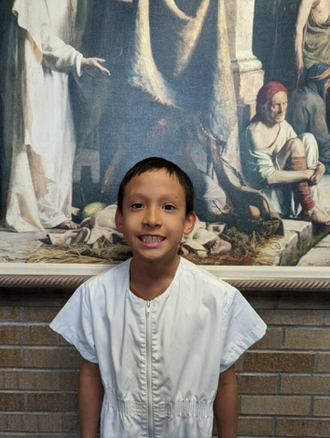

April 30 – Avalon Garritson Baptism:
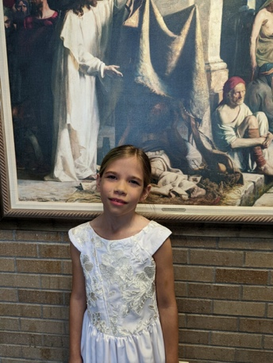
May 7 – Service project at Bitton’s

May 22 – Holman’s were called as Senior Service Missionaries, Jordan Institute
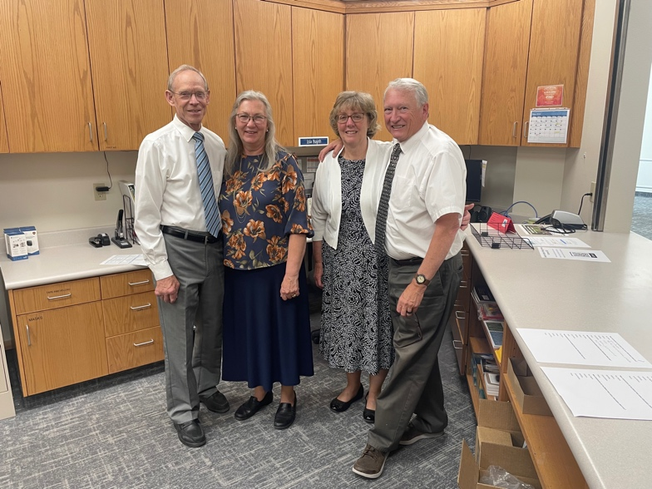
June 10 – Ward Campout

Brenda Drake
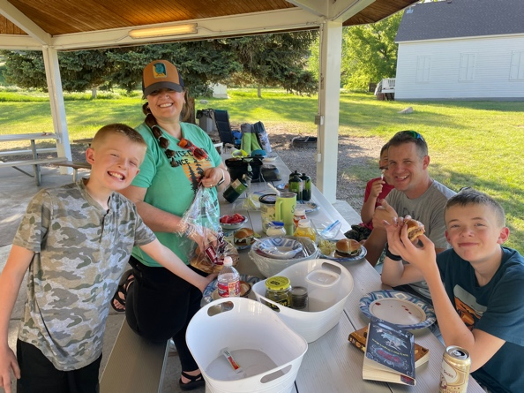
Josh Erin Kendall Sam Johnson
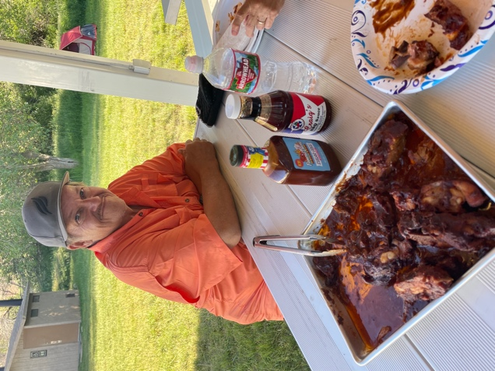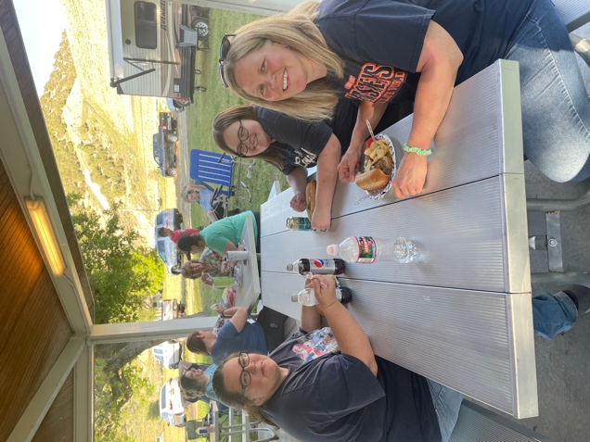
Todd Larson Natalie & Addison Smith, Debra Ekker
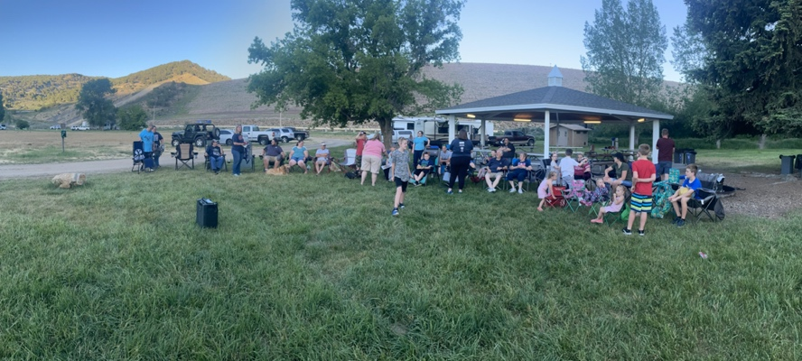
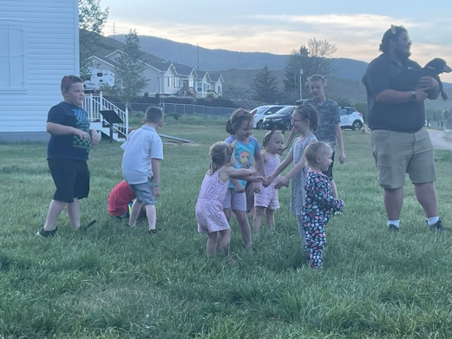
Zachary Smith Donovan Goodwin

Olivia, Wes Butterfield
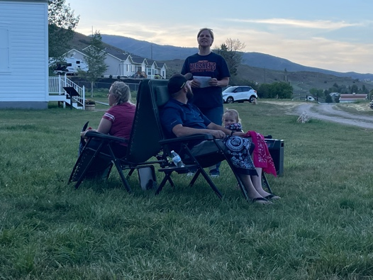
Michelle & Wes Butterfield, Debra Ekker
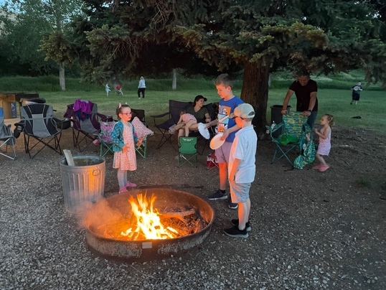
Ava Butterfield, Hayden Bona, Liam Butterfield
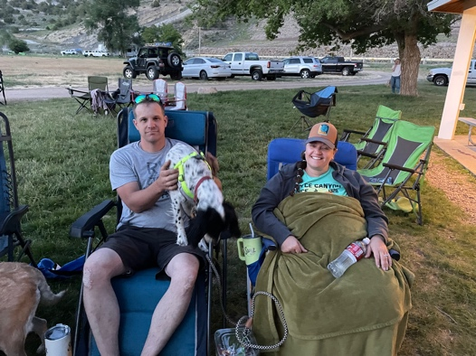
Kendall & Erin Johnson
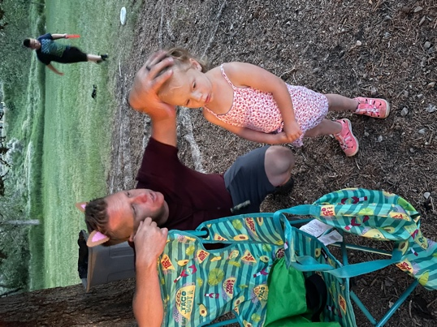
Hattie & Joey Bona
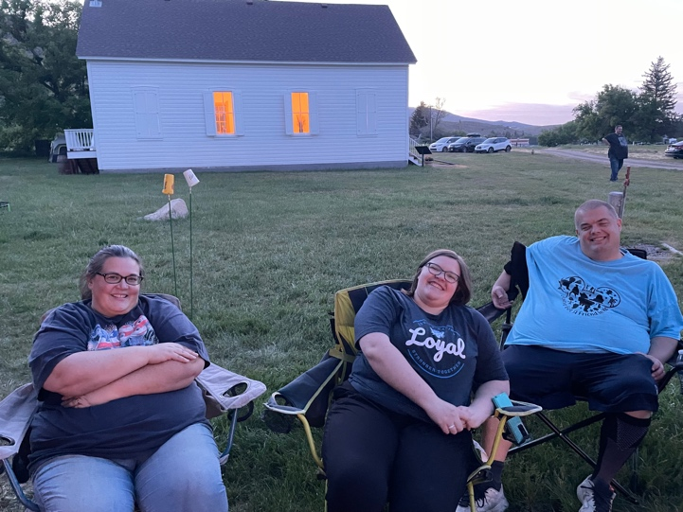
Natalie Addison & Bret Smith
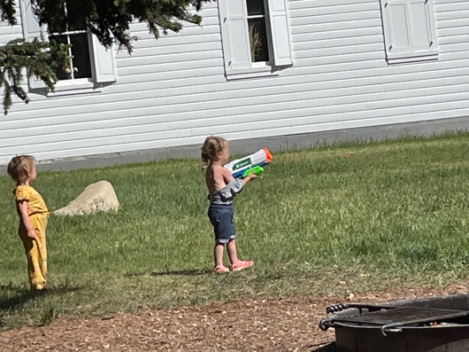
Olivia Butterfield & Nora Bona

June 23 – Tree stump removal at Davis’
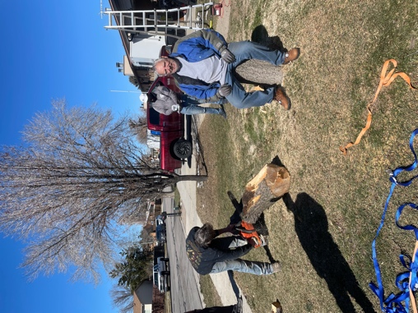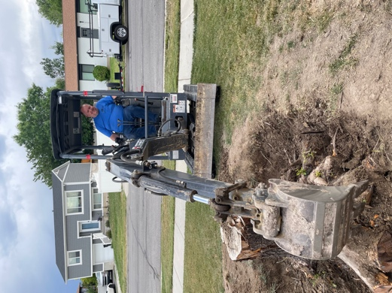
Dave Davis Gary Olson
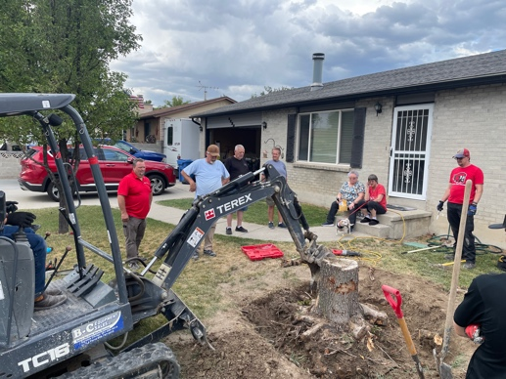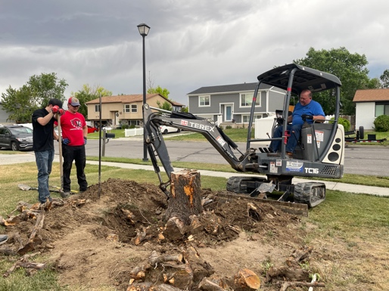
John Beverley, Dennis Blumenkrantz, Dave Davis Isaiah Fowers, Brady Patterson, Gary Olson
Todd Larson Connie Yeates Mary Davis Brady Patterson

July 10 – New Bishopric
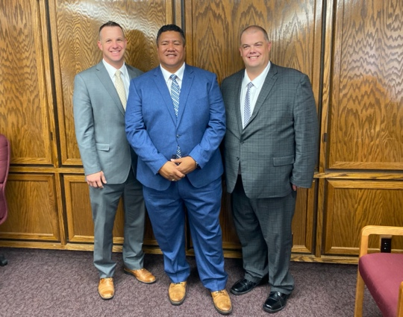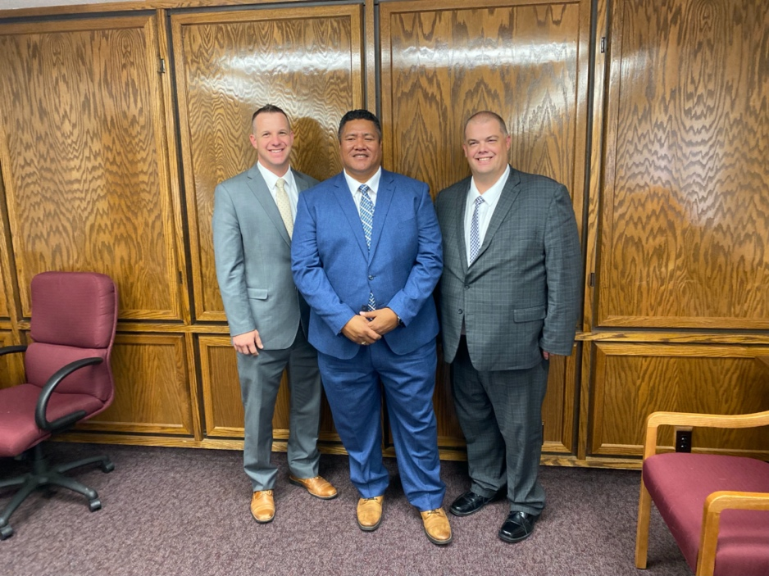
Brett Smith, Bishop Brent Malili, Kendall Johnson

Bishop Ekker conducted and welcomed the congregation. After the opening hymn and prayer, Wes Butterfield was called to work in the young men’s. The time was turned over to President Prescott for the stake business:
Matt Ekker was released as Bishop, Kurt Allen as 1st Counselor and Brett Smith as 2nd Counselor.
Brent Malili was called as Bishop, Kendall Johnson as 1st Counselor and Brett Smith as 2nd Counselor.

Aug 27 – Ward Golfing
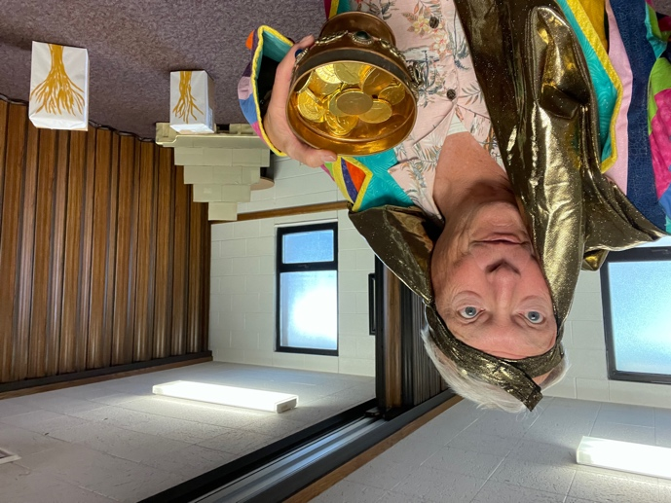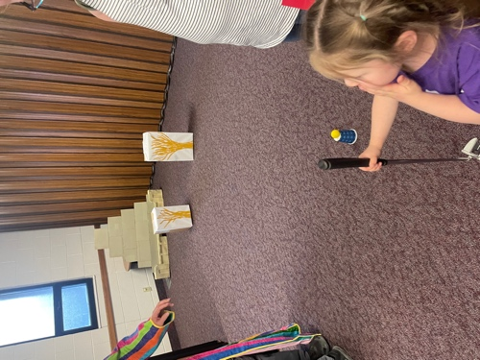
Bruce Holman as Joseph Noelle Christensen
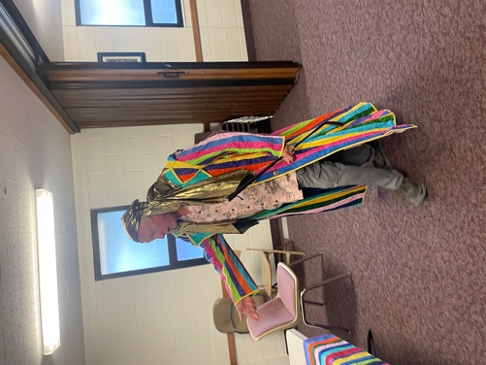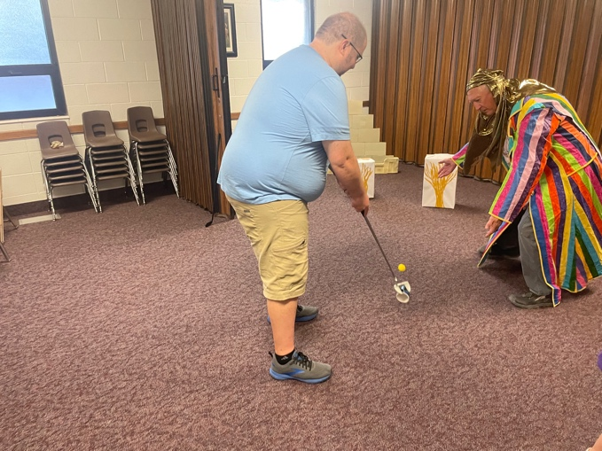
Bruce Holman Mike Christensen
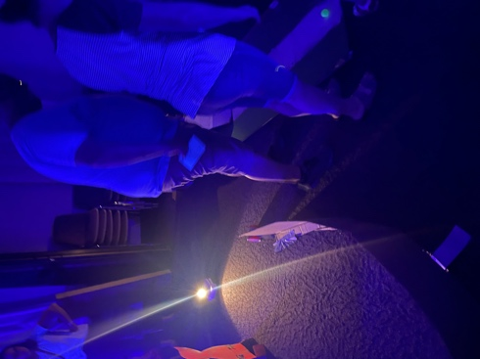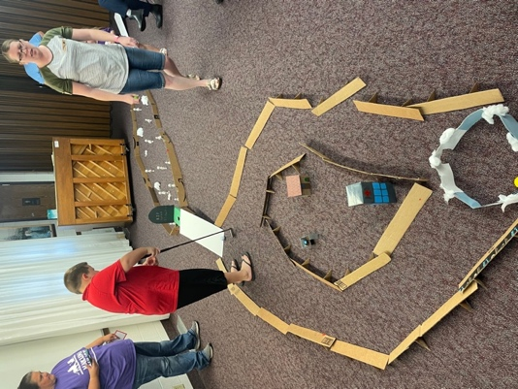
Natalie & Zach Smith, Rachel Christensen
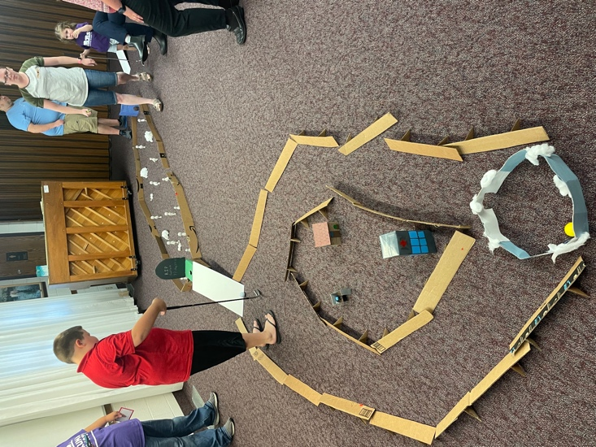
Zach Smith, Mike Rachel Noelle Christensen
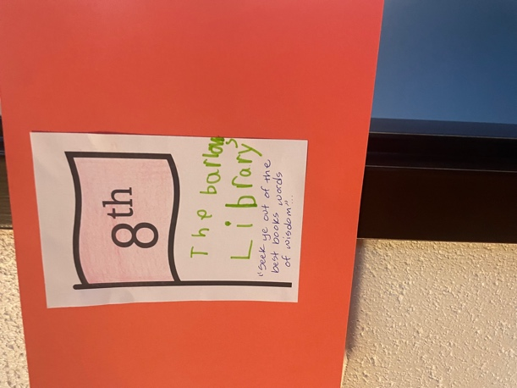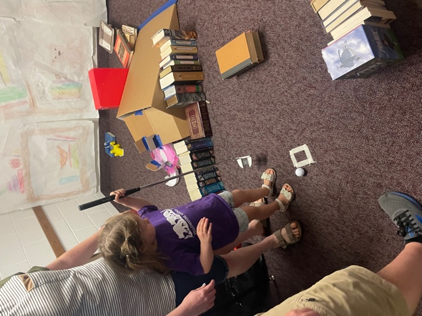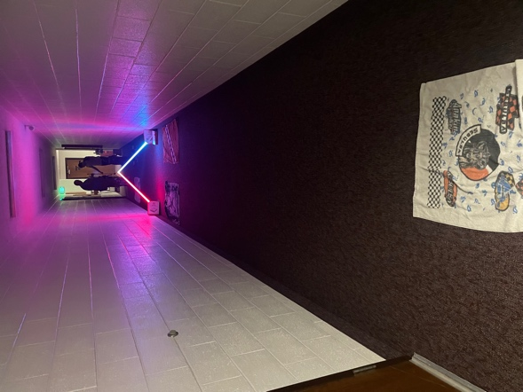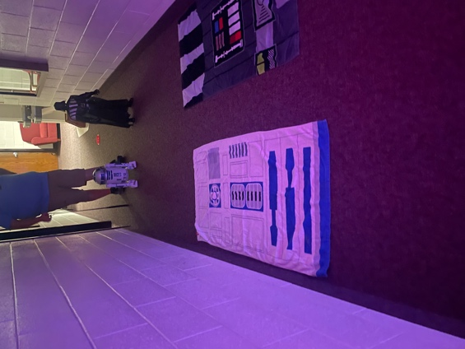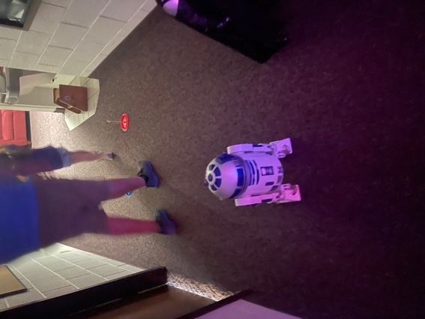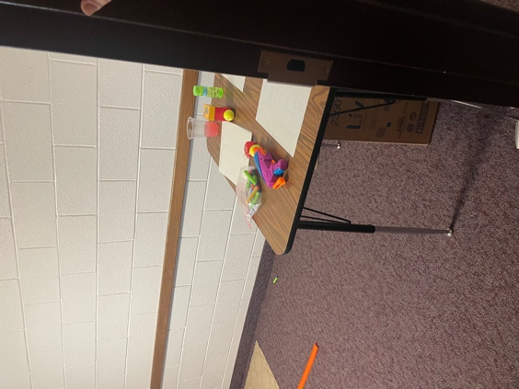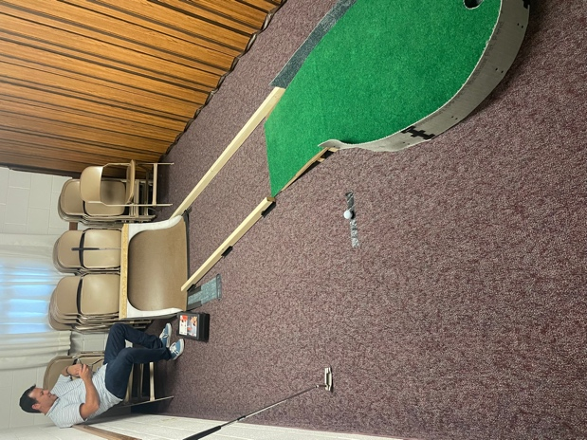

Sep 9 – Donovan Goodwin/Austin Olson Shower
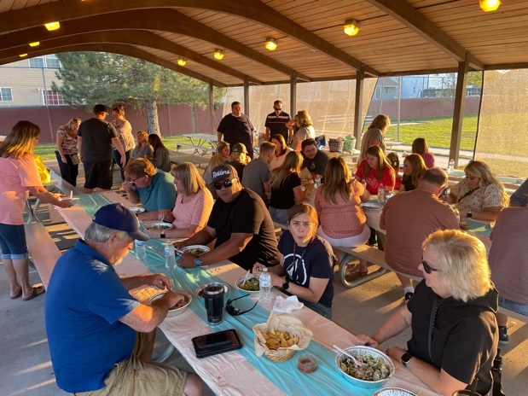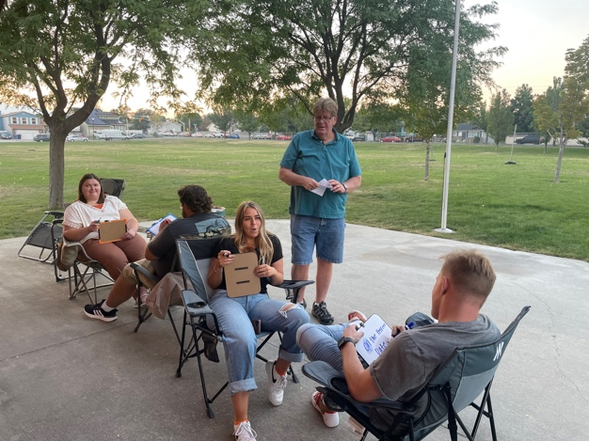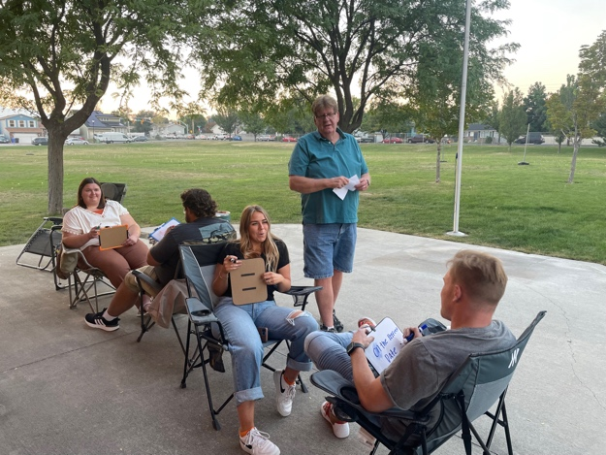
Hailey & Donovan Goodwin, Steve Paxman, Kelsey & Austin Olson
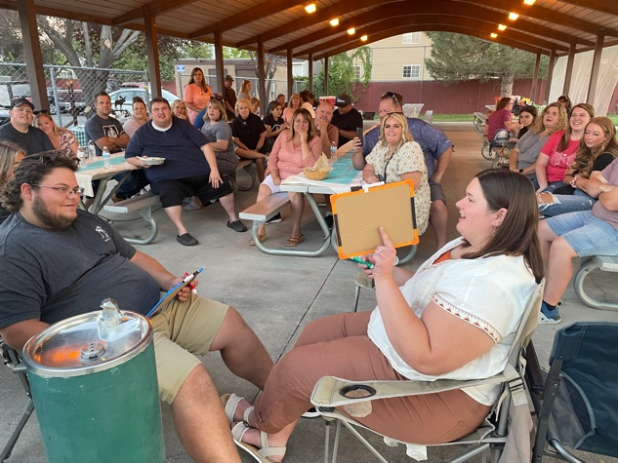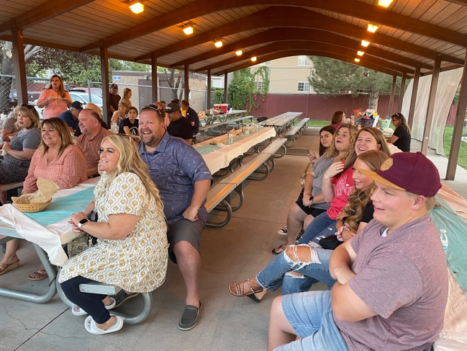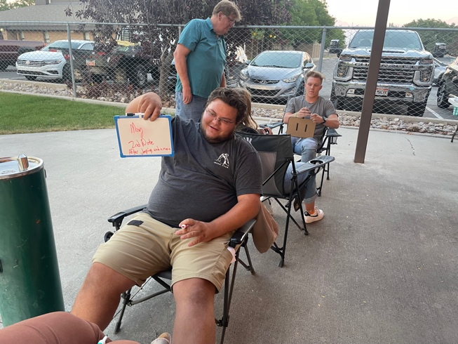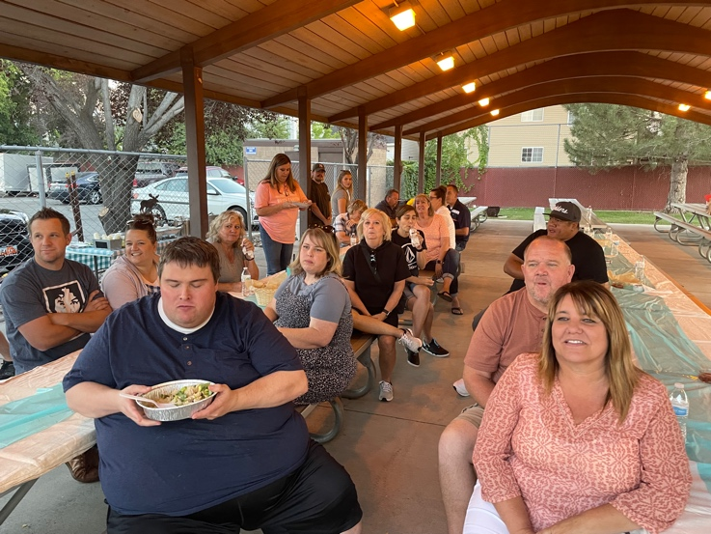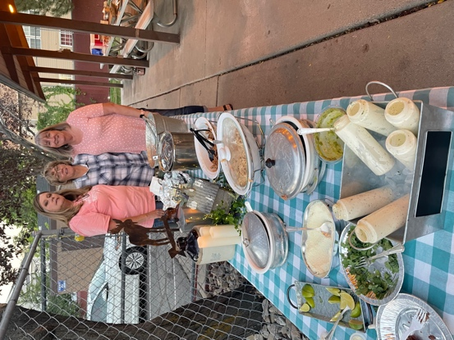
Anne Paxman Susan Holman Cathy Blumenkrantz

October 29 – Trunk or Treat
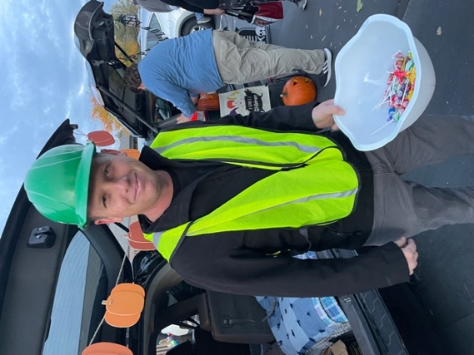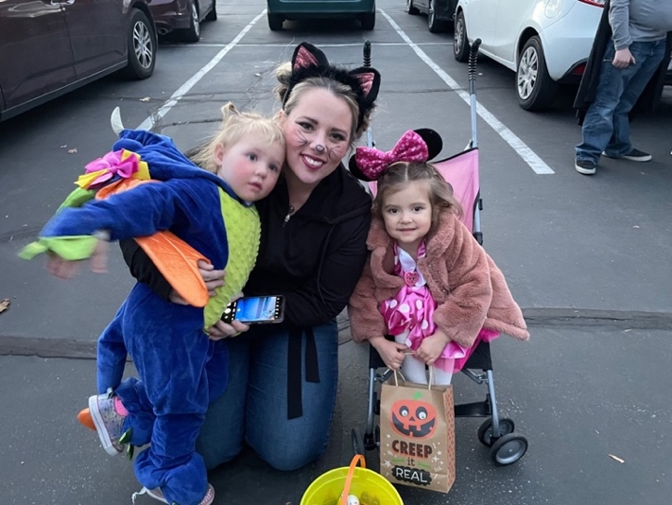
Joey Bona Olivia & Michelle Bona, Lili Senior(Holman grand-daughter)

Nov 2 - Primary Carnival
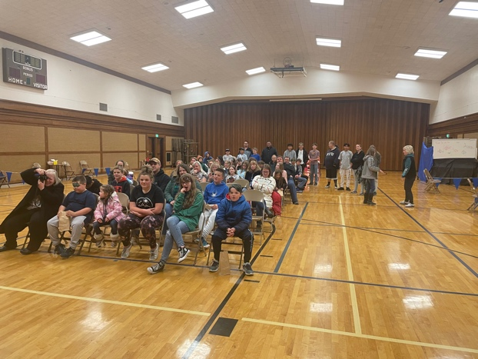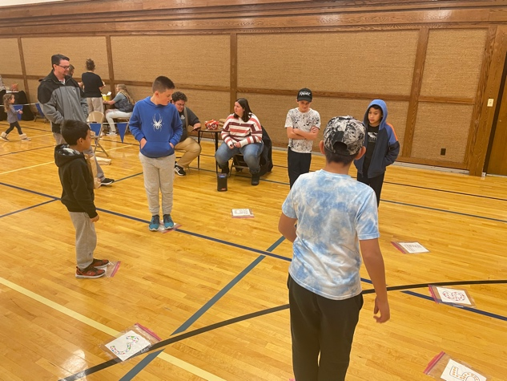
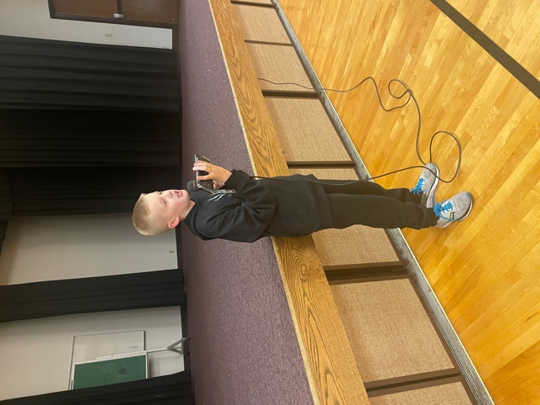
Josh Johnson
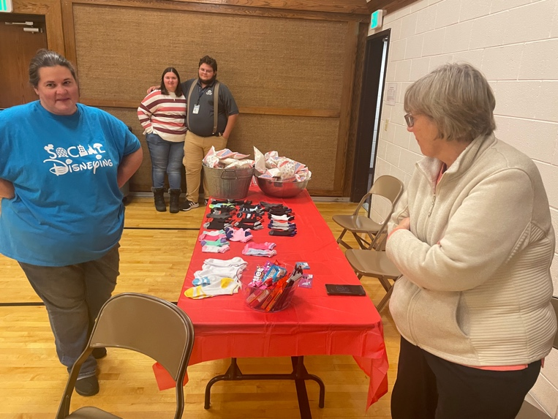
Susan Holman, Donovan & Hailey Goodwin, Natalie Smith
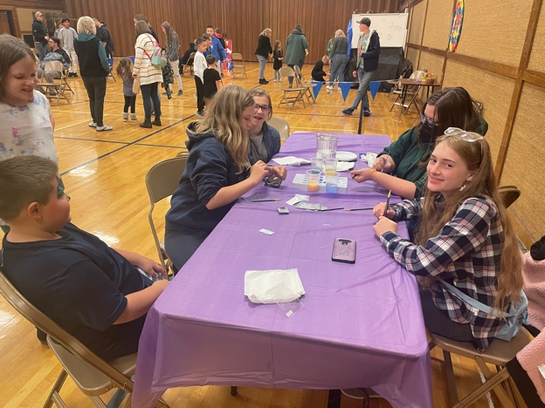
Autumn Garritson, Zach Smith, Afton Garritson, Natasha Barlow
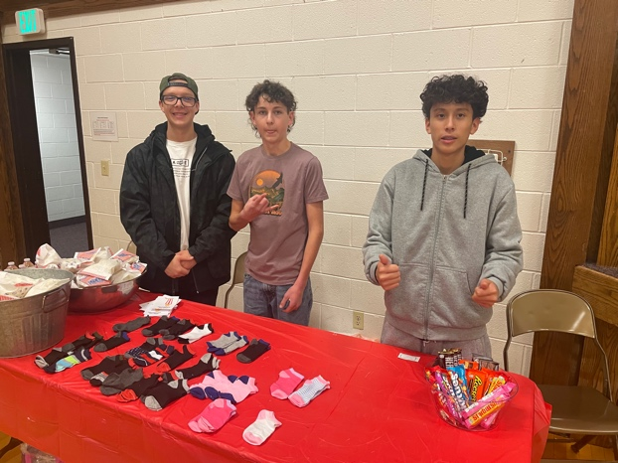
Isaac Turner, Nicholas Stowe, Aaron Flores
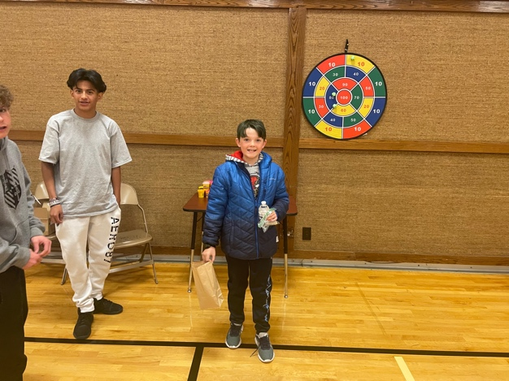
Axel Martinez, Jamison Patterson
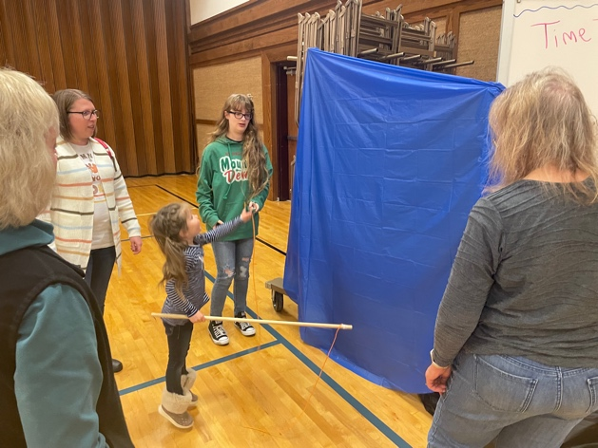
Rachel & Noelle Christensen, Riley Barlow
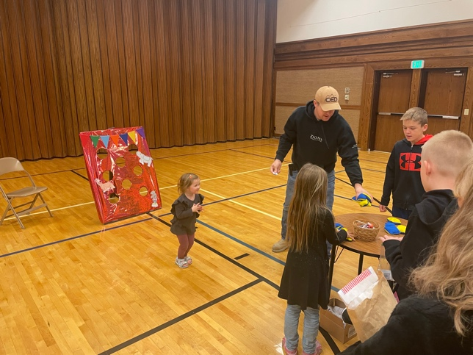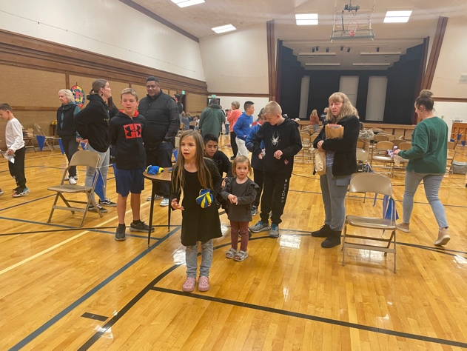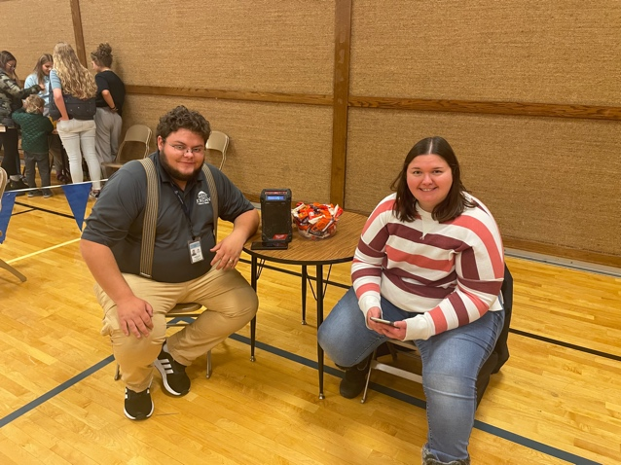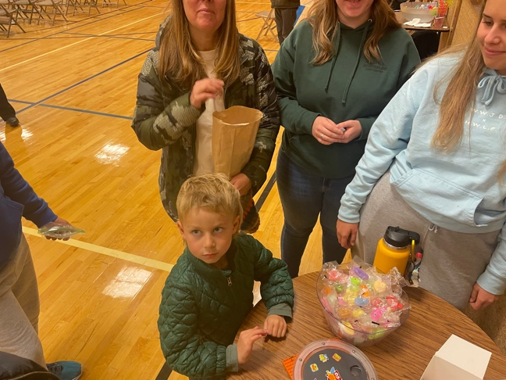
Donovan & Hailey Goodwon Sam Stowe

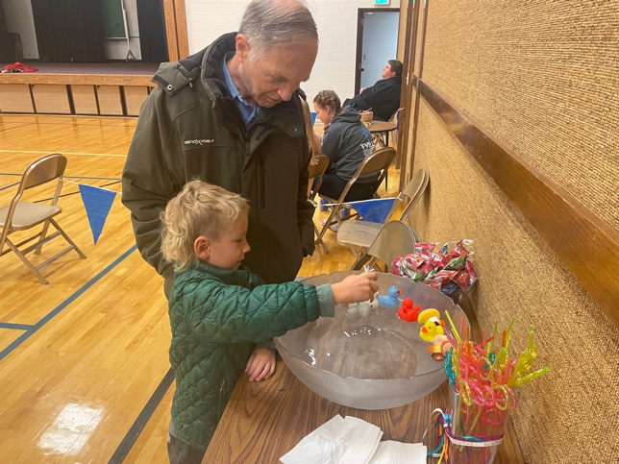
Darrell Meier, Sam Stowe
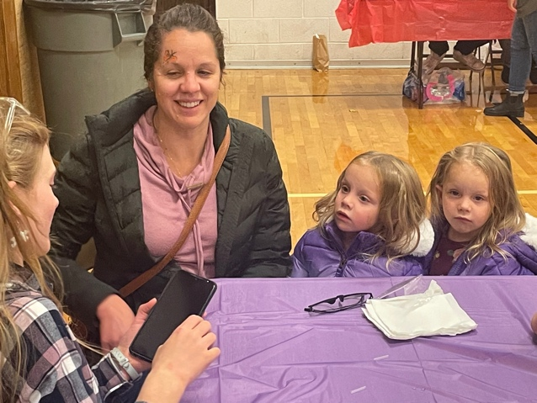
Nora Hattie Natalie Bona
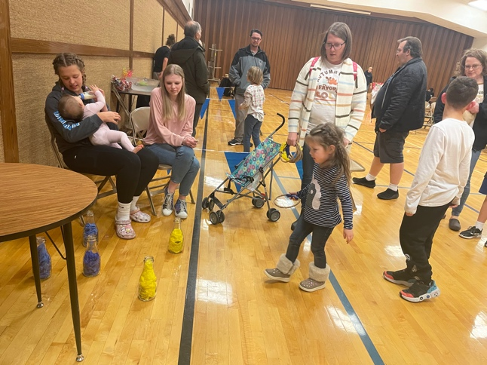

Dec 9 – Ward Christmas Party
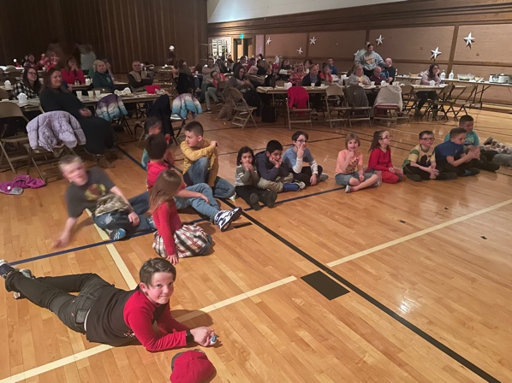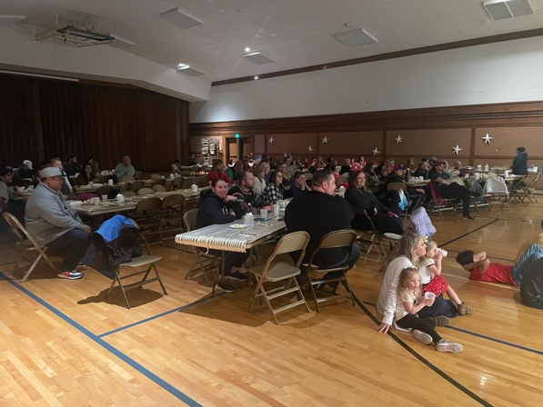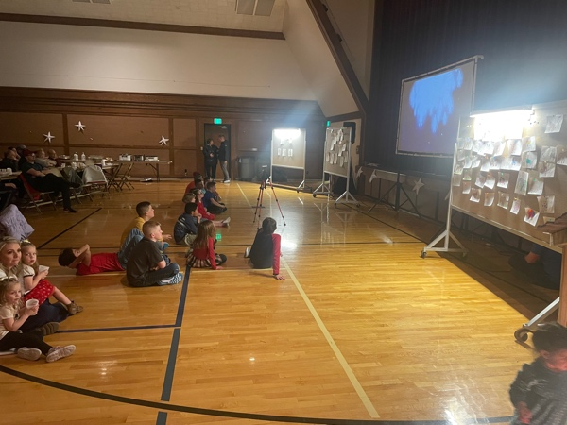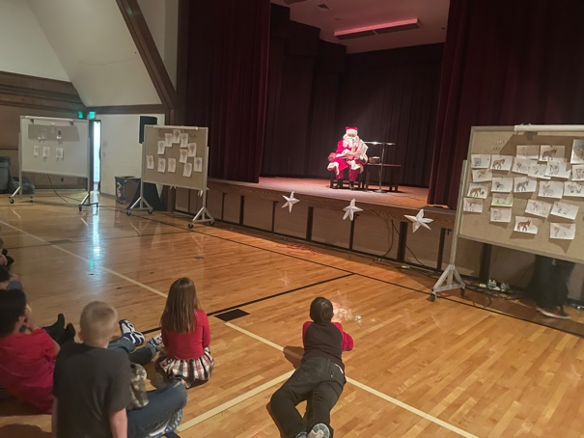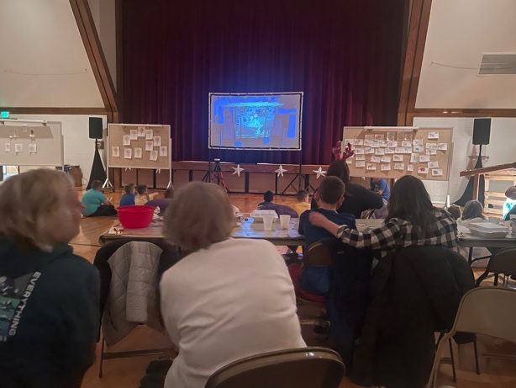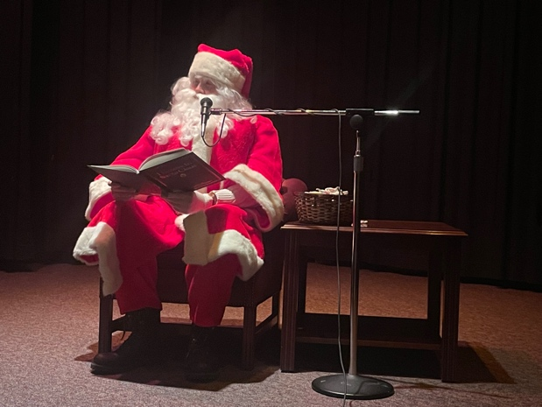

Dec 10 - Zachary Smith Baptism
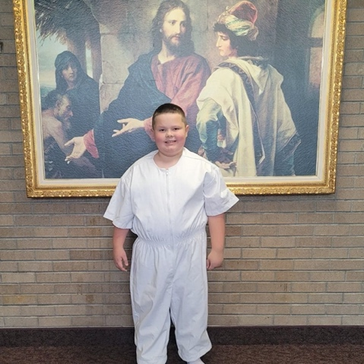

Organizational Histories

Elder’s quorum:
Relief Society:

Primary:
Primary History 2022
This year we studied the Old Testament, the children enjoyed learning and singing about the prophets old. Our Primary is very small, so each class is combined with another making four combined classes.
Birthdays
Each child was given a “Come Follow Me” Bracelet and Pop Rock Candy that said,
“Birthday’s Rock and so do you, Always remember The Church is true!” We gave the teachers big candy bars and wished them a “Sweet birthday!”
Baptisms
We held our “It’s Great to be 8!” baptism preview on January 9th for the children getting baptized and their parents. Megan Cannon there to talk about and invite them to Activity Days, President Goodwin talked about preparing for their baptism day, and Bishop Ekker talked about the baptism interview and passed out their emblems of belonging ring and temple picture. We had 3 Children get baptized this year. Avalon Garritson in March, Jose Flores in April, and Zachary Smith in December. Each child had great support from family, friends and ward members with great talks and musical numbers that helped bring the spirit. As a primary we continued to pass out note cards from those in attendance to write a note or share a testimony with the child being baptized. We also continued to give them the pillowcase with the children and youth emblem and pillowcase poem as well as a framed picture of the temple with their name and baptism date.
Activity
This year we had a fun Carnival/Talent show in November where the children used the reverence tickets that they had earned throughout the year to during primary. They used the tickets for games, face painting and for treats. There were a couple of children that wanted to do a talent show so we did that before starting the games. Zach Smith played the piano, Autumn Garritson played the violin and Josh Johnson told jokes. We had great attendance from primary kids and families as well as the teachers, youth and leaders that help run the booths.
Primary Program
After our program was pushed back multiple times for multiple reasons we finally had it on Sunday November 20th with a practice the day before. The program practice is always a little crazy but worth it as it helps us make any adjustments needed. After the practice the kids enjoyed a donut for a reward! Although the practice is crazy the program is always turns out wonderful. The children wrote their own parts for the program and really enjoyed learning some different songs this year. Some of the favorites were Peace in Christ, I will walk with Jesus (sung by primary kids, youth and leaders), If the Savior Stood beside me flute played by Barbara Shelton and Liken the Scriptures. We also had some special Musical numbers The Barlow family sang Teach me about the temple, Zach Smith sang When I am Baptized, Charlotte & Ethan Bona and Liam & Ava Butterfield sang I’m trying to be like Jesus. Listening to the children sing and share testimonies brings a special spirit to the meeting.
Temple and Priesthood Preparation
We organized the Temple and Priesthood Preparation meeting for the children that would begin attending YMYW next year. The YMYW leaders, Bishopric and Family History leader spoke to the kids about what to expect in the coming year as they enter YMYW.
Christmas
This year we gave the kids candy and each piece referencing a way to remember the Savior.

Ward Mission:
Ward Young Men:
Young Women:
Sunday School:

Westbrook 5th Ward Leadership History

Bishops
Gale Searle ‘84
Scott Rosenlof ‘89
Bruce Holman ‘94
Glen Johnson ‘99
Brad Bona ‘04
Lloy Romrell ‘09
Matt Ekker ‘16
Brent Malili ‘22
H. P. Group Leader
Jarl Jacobson ‘84
Gaylan Luke ‘87
Darrell Meier ‘88
Chris Emmons
Joe Linford
Kelvin Meier
David Goddard
Craig Pendleton
Glen Johnson
Sheldon LaMont
Lloy Romrell
Scott Rosenlof
Jerry Paul
Ryan Stowe ‘16

E. Quorum President
Bruce Despain ‘84
Todd Barrett
Brian Garner
Bruce Holman ‘89
Sheldon LaMont
Glen Campbell
Joseph Bradley
Steve Neff
Brett Fowers
Kurt Allen
Jess Hansen ‘16
Jess Hansen ’18 recalled
Jarl Jacobson ‘21
Relief Society President
Elaine Hendrickson ‘84
Sarah Meier
Jolene Brown
Danette Crawford
Teresa Anderson
Janet Willes
Debbie Luke
Diane Romrell
Anne Paxman
Corey Neff
Debbie Woolsey
Debbie Ekker
Sarah Meier
Megan Cannon
Shanna Hansen ‘21

Primary President
Paula Osgathorpe ‘84
Ann Garner
Lisa Barrett
Diane Romrell
Connie Hal
Cathy Blumenkrantz
Stephanie Monson
Laura Dixon
Martha Armstrong
Debbie Ecker
Launa West
Michelle Bell
Tiffany Bona
Rebekah Goodwin ‘19
Young Men President
Ken Allred ‘84
Richard Hendrickson ‘87
Jeff Terry ‘88
Doug Mechling
Todd Crawford ‘90
Lloy Romrell
Monte Searle
Gaylan Luke
Brent Sabey
Scott Rosenlof
Brad Bona
Rich Simpko
Kelvin Meier
Gary Olson
Moysh, Scott
Matt Cannon
Matt Hoffer
Joey Bona ‘16

Young Women President
Collett Ashcroft ‘84
Monique Nielsen ‘87
Shawna Faulkner ‘88
Sherry Price ‘90
Debbie Luke
Anne Paxman
Janet Willes
Jill Owen
Debbie Woolsey
Dee Bulkley
Debbie Bona
Melanie Tripp
Erin Johnson
Natalie Bona ‘21

Scout Master
Ken Allred
Dave Goddard
Scott Rosenlof
Jerry Paul
Gary Olson
Jess Hansen
Moysh, Scott
Ken Bulkley
Brett Fowers
Kendall Johnson
Dennis Blumenkrantz
Andrew Cross
Joel Potter
Jason Tomlinson

Mission Leader
Gordon Gudmundson ‘87
Brian Woolsey ‘89
Gilbert Fortune ‘90
Daryl Meier
Kelvin Meier
Craig Pendleton
Steve Paxman
Gaylan Luke
John Roberts
Brad Bona
Bruce Holman ‘15
Sheldon LaMont ‘18

The old 51st ward met the first time after being separated from the 22nd ward, on April 29, 1984. We met in the Dixie valley chapel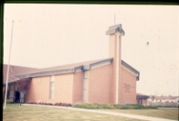 until the new stake center was finished in late 1985.

Bishop Gayle Searle 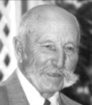was called as Bishop with Doug Mechling 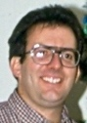as 1st Councilor and Darryl Meier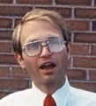 as 2nd Councilor.
Scott Rosenlof was called as Bishop in 1989 with Jarl Jacobson as 1st Councilor and Kurt Devries as 2nd Councilor.
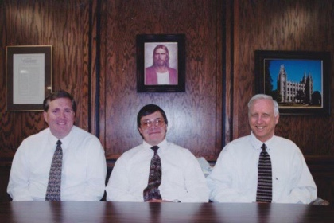
Bruce Holman was called as Bishop in 1994 with Brad Bona as 1st Councilor and Ryan Ireland as 2nd Councilor.
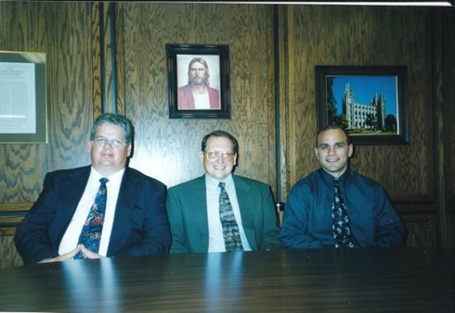
Glen Johnson was called as Bishop in 1999 with Lloy Romrell 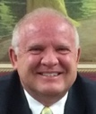 as 1st Councilor and Monte Searle 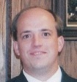as 2nd Councilor.

Brad Bona was called as Bishop in 2004 with Sheldon LaMont as 1st Councilor and Brian Woolsey as 2nd Councilor.
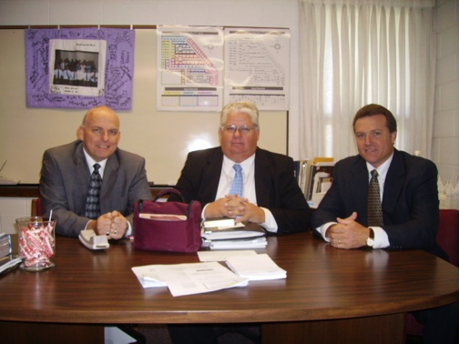

Lloy Romrell was called as Bishop in 2009 with Gary Olson as 1st Councilor and Ryan Stowe as 2nd Councilor.
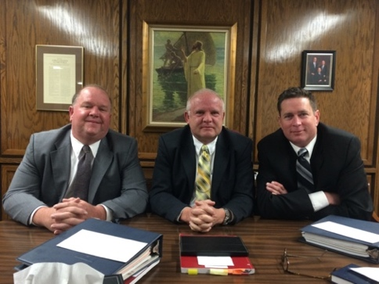
Matt Ekker was called as Bishop in 2014 with Kurt Allen as 1st Councilor and Matt Hofer as 2nd Councilor.
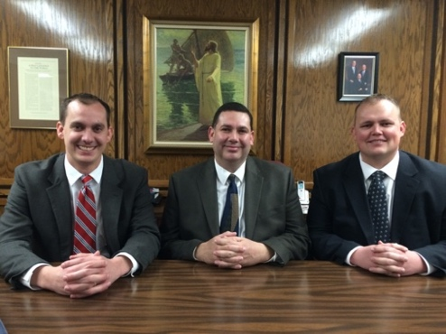

Previous Year’s Father’s & Son’s:
