*“Unprecedented times require unprecedented measures.”*

President Russell M. Nelson, October 2021 Conference

**Understanding, remembering and practicing correct principles enable us to do better, to prepare better and help others better. The Church of Jesus Christ of Latter Day Saints has prepared timely courses designed to help all of us navigate these unprecedented tim**es

**Come join a Self-Reliance Class**

**Emotional Resilience - January 2022**

**Personal Finance – January 2022**

**Life Skills – January 2022**

Other Courses Available Upon Request

Find a Better Job

Education for Better Work

Starting and Growing My Business

When emotional earthquakes, financial earthquakes or spiritual earthquakes occur, those who are prepared will not fear.

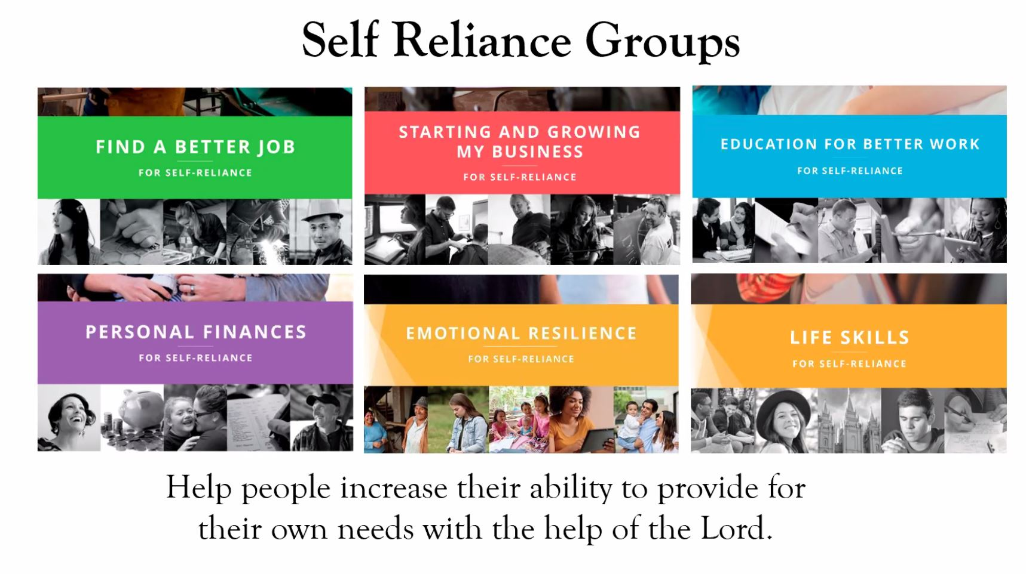

**Contact a member of your Bishopric, Relief Society Presidency, Elders Quorum Presidency or your Ward Self-Reliance Specialist for details**